3 Branches of Government Literacy Groups
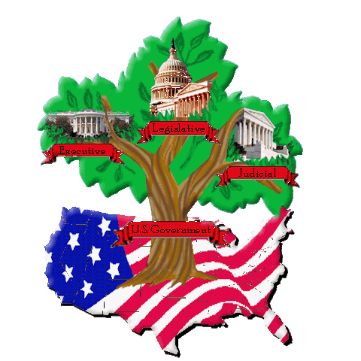
Student Names _____________________________________________________________________________________
Date _____________________________________ Block _______________________
Instructions: Each member of the group will choose a role to take on for your literacy group. Watch the video and read the texts, then discuss and answer the questions as a group. You will find the video and text on the website https://sites.google.com/a/bertie.k12.nc.us/3-branches-of-the-federal-government/ . Write down your groups responses on this sheet, be prepared to share and then turn in your work for a project grade.
Group Roles
- Director: Responsible for leading discussion of the questions and keeping the group on task.
- Recorder: Responsible for recording the groups ideas and answers to the questions.
- Reporter: Responsible for sharing the groups ideas with the rest of the class during class talk.
- Vocabulary Investigator: Responsible for researching and explain difficult vocabulary words from the reading.

Source # 1 (Short Video): http://www.youtube.com/watch?v=ZCB8EOY5d48
1. Can you summarize what the video teaches about the federal government?

2. Do you think Mr. G could make a better music video? Could you?

Source # 2 (Online Article): http://www.cnn.com/2013/09/13/opinion/donohue-gun-control/index.html?hpt=po_c2
Legislative Branch: the branch of government that makes our laws
1. What is the author's opinion on the NRA (National Rifle Association)?

2. What is the author's message for those who already own guns?

3. What do you think should be the process in order for someone to purchase and own a gun in the United States?

Source # 3 (Online Article): http://politicalticker.blogs.cnn.com/2013/09/11/sen-corker-slams-obama-on-credibility/
Executive Branch: the branch of government that executes, carries out, our laws
1. Why is Senator Corker upset with President Obama?

2. Do you think that President Obama has done a good job as the 'Commander in Chief' of our military? Why?

3. What do you think the US should do about the crisis in Syria? (Syria is in a civil war because many of the people want to overthrow the dictator of Syria, Assad, while others want to keep him in power. Assad and his government are being accused of using chemical weapons on the people of Syria to stop them from rebelling.)

Source # 4 (Online Article): http://politicalticker.blogs.cnn.com/2013/09/06/biden-wants-napolitano-on-supreme-court/?iref=allsearch
Judicial Branch: the branch of government that interprets the actual meaning of our laws
1. What is the main point of this brief article?

2. Based on the article, why might Napolitano make a good candidate to be a Justice on the Supreme Court?

3. What do you think should be the required qualifications for someone to be chosen to serve on the Supreme Court?

4. Why is it such a big deal when the President chooses new Justices to serve on the Supreme Court?

