Essay Response on Jackie Robinson
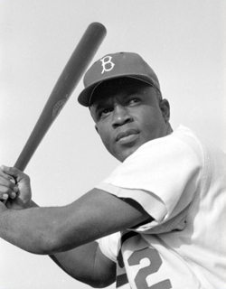

Student Name __________________________________________ Date ___________________________ Block ______
Instructions: Use your learning about Jackie Robinson through class discussion, literacy groups and film to help you write a brief essay response. Your essay should be at least 3 well-written and organized paragraphs and it should fully answer the following question: “How has examining the life of Jackie Robinson enhanced your understanding of African-American Studies?” You should type up your essay response and email it to (share it with) Mr. Gay by the due date. You will submit this paper on the due date and your work will be graded according to the following rubric.

 | Excellent (10) | Average (8) | Poor (6) | Incomplete (0)
Did your essay fully respond to the question: “How has examining the life of Jackie Robinson enhanced your understanding of African American Studies? | The essay clearly and accurately addresses the question, while also providing examples that support the student’s ideas. | The essay addresses the question, but the student is either not very clear, not very accurate, or doesn’t provide examples. | The essay is not clear and accurate and it doesn’t provide examples. | Incomplete. Not turned in.
Is your essay at least 3 well-written and organized paragraphs? | The essay consists of at least 3 paragraphs that have good sentence structure and are well organized. | The essay consists of at least 3 paragraphs but they are not very organized or well written. | The essay does not meet the requirement of at least 3 paragraphs and is not well written. | Incomplete. Not turned in.
Does your essay demonstrate a truly thoughtful and original response? | The essay clearly demonstrates that the student put effort and original thought into their response. | The essay shows that the student shared a little bit of their thoughts, but clearly didn’t put much effort into it. | The essay shows that the student did not put real thought or effort into their response. | Incomplete. Not turned in.

_______________ Essay Response Score (Out of 30 points available)

