Questions for the Film: Glory
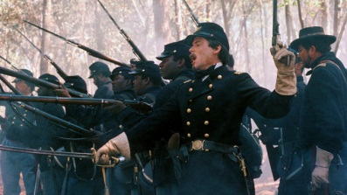
The 54th Massachusetts Regiment

Student Name __________________________________ Date ______________________ Block ______
Instructions: As a class we will watch the film ‘Glory’ and discuss the 54th Massachusetts Regiment. By watching the film and participating in class discussion, you should be able to answer the following questions. Be sure to give thoughtful responses with plenty of explanation, detail and examples to support your answers.
Description of ‘Glory’: The story is based on the 54th Massachusetts Volunteer Infantry, the first formal unit of the US Army to be made up entirely of African American men. It is told from the point of view of Colonel Robert Gould Shaw, the 54th’s commanding officer during the American Civil War.

- Based on the opening battle scenes, what type of image of the Civil War are the filmmakers trying to create?

- Explain Shaw’s feelings about leading the 54th?

- How would you describe the men who volunteered to serve in the 54th? Why?

- What kind of difficulties do the men in the 54th face during their training?

- How do they respond to these difficulties?

- What kind of difficulties do the men in the 54th face after their training is finished and they are deployed to the South?

- How do they respond to these difficulties?

- Why was it so important to Shaw and the men of the 54th that they get to fight in battle?

- The film ends with the climactic battle at Fort Wagner. After watching the scenes from this battle, what kind of message about the 54th do you think the filmmakers were trying to communicate to the audience?

- Why is the story of the 54th so significant to African-American History?

- What do you think was one of the most important scenes of the movie and why do you think it was so important?

