Questions for the Film: 42
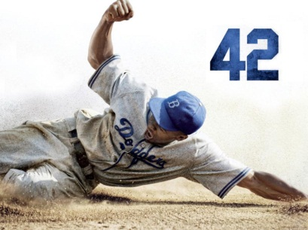
Student Name __________________________________ Date ______________________ Block ______
Instructions: As a class we will watch and discuss the film ‘42’, which is about Jackie Robinson and how he broke the color barrier that existed in Major League Baseball during the 1940s. By watching the film and participating in class discussion, you should be able to answer the following questions. Be sure to give thoughtful responses with plenty of explanation, detail and examples to support your answers.

- How did Branch Rickey, owner of the Brooklyn Dodgers, decide that Jackie Robinson was the right man to play for the Brooklyn Dodgers?

- Why do you think some white players were so upset about playing with or against Jackie Robinson?

- What kind of hardships did Jackie go through as a black man playing professional baseball?

- What was the importance of Robinson’s relationship with his wife, Ray?

- What do you think would have been the effects had Robinson retaliated against mistreatment during his first season with the Dodgers?

- How did the film help you have a better understanding of racism and segregation that existed in the United States during the late 1940s?

- What was the significance of the moment when Pee Wee Reese, the Dodgers shortstop, put his arm around Jackie Robinson while they were on the field in front of the fans?

- What was the reason(s) that Branch Rickey made the decision to bring in an African-American baseball player to play for the Brooklyn Dodgers?

- Can you summarize what you think the filmmaker’s main message was in the movie?

- Can you create two discussion questions that you would like to ask your classmates about Jackie Robinson / the film ‘42’?

