“Please Vote for Me” Video and Discussion
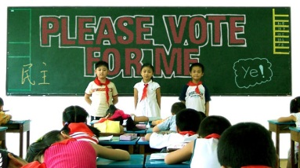

Student Name: _________________________________________ Date ___________________ Block ______
Instructions: As you engage in the short documentary “Please Vote for Me”, look over your questions and respond based on your ideas and what you’ve learned through the video. Be prepared to share your answers.
- Before watching the video, what is your general idea of what life is like for people in China?

- Also before watching the video, what is your idea of what the government is like in China?

- How is a Chinese 3rd Grade class different and similar to your own 3rd grade experience?

- Based on the video what are the potential positives and negatives of holding a democratic election?

- Who do you think will win the election? Why? (Circle your answer.)
  - Xiao Fei (The Girl)
  - Luo Lei (The Smaller Boy Who Has Already Been the Class Monitor)
  - Cheng Cheng (The Larger Boy Who Walks Around in His Underwear at Home)

- Who actually won the election? Why do you think he / she won? (Circle your answer.)
  - Xiao Fei (The Girl)
  - Luo Lei (The Smaller Boy Who Has Already Been the Class Monitor)
  - Cheng Cheng (The Larger Boy Who Walks Around in His Underwear at Home)

- How did this documentary enhance your understanding of democratic elections?

- How did this documentary enhance your understanding of the Chinese people and their culture?

