‘The OJ Simpson Trial’ Literacy Groups
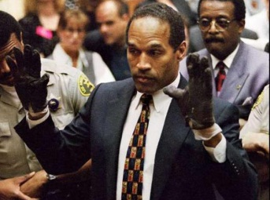
Student Names _____________________________________________________________________________________
Date _____________________________________ Block _______________________

Instructions: Each member of the group will choose a role to take on for your literacy group. Watch the videos and read the texts, then discuss and answer the questions as a group. You will find the video and text on the website https://sites.google.com/a/bertie.k12.nc.us/the-oj-simpson-trial/. Write down your groups responses on this sheet, be prepared to share and then turn in your work for a project grade.
Group Roles
- Director: Responsible for leading discussion of the questions and keeping the group on task.
- Recorder: Responsible for recording the groups ideas and answers to the questions.
- Reporter: Responsible for sharing the group’s ideas with the rest of the class during class talk.
- Vocabulary Investigator: Responsible for researching and explain difficult vocabulary words from the reading.

Source # 1 (Online Article) Nicole B. Simpson and Ronald Goldman Murdered: http://www.history.com/this-day-in-history/nicole-brown-simpson-and-ron-goldman-murdered
- What crime was OJ Simpson accused of in 1994?

- What evidence suggests that Simpson is guilty of killing Nicole and Ronald?

- Based on the article, what strategy did OJ Simpson’s defense lawyers use in order to defend him against the charges being brought against him?

- Though found not guilty in criminal court, Simpson was later found guilty of killing Ronald Goldman in a civil court. His punishment was that he was ordered to pay $33 million dollars to the Goldman family. What does your group think about that?

- What is OJ Simpson up to now?

Source # 2 (Online Video) Memorable TV Moments: OJ Simpson Verdict: http://www.youtube.com/watch?v=WcsGZyeBo-s
- Why do you think the OJ Simpson Trial grabbed the attention of the United States like it did?

- Based on the video, what did OJ Simpson’s lawyers claim to be the reason(s) why he was found not guilty?

- The OJ Trial was by far the biggest court case in the news when Mr. Gay was your age. Can you think of any trials that have grabbed the nation’s attention during your generation so far? Why were so many people interested in that trial(s)?

Source # 3 (Online Article) Simpson Trial Draws Jeers ‘Round the World: http://www.cnn.com/US/OJ/verdict/world/index.html
- Based on the article, how did the majority of other countries react to the OJ Simpson Trial and Verdict?

- In your opinion, what does the OJ Simpson trial say about the United States judicial system?

- Do you think our country is moving closer to or further away from better race relations? Why?

*Can you think of two discussion questions about the OJ Simpson Trial that you would like to discuss with your classmates? Write them down here.

1.

2.

