Literacy Groups: African-Americans in the New Nation
“Examining the Lives of Crispus Attucks, Phillis Wheatley, Elizabeth Freeman, and James Forten”
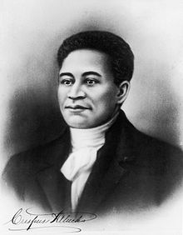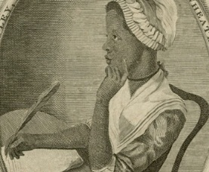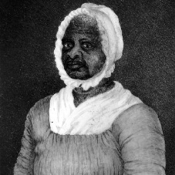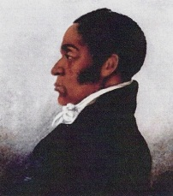
Student Names _____________________________________________________________________________________
Date ____________________________________________ Block ________________
Instructions: Each member of the group will choose a role to take on for your literacy group. Everyone should read the content, then discuss and answer the questions as a group. The assigned readings are in the textbook. Write down your groups responses on this sheet and turn it in for a project grade. Be prepared to share your answers and ideas.
Group Roles
- Director: Responsible for leading discussion of the questions and keeping the group on task.
- Recorder: Responsible for recording the group’s ideas and answers to the questions.
- Reporter: Responsible for sharing the group’s ideas with the rest of the class during class talk.
- Vocabulary Investigator: Responsible for researching and explaining difficult vocabulary words from the reading.

1st Reading: Crispus Attucks, page 113
- How would you describe Crispus Attucks’ background?

- What is his involvement with the American Revolution?

- Following his death, in what way have Bostonians viewed him?

- What does his story teach us in our study of African-American history?

- Can your group create one discussion question for your classmates about Crispus Attucks?

2nd Reading: Phillis Wheatley, page 119 – 120
- In what ways was Phillis Wheatley’s experience as a slave much more fortunate than many other slaves?

- Phillis seemed to believe that it was God’s merciful plan that she be taken from Africa as a young girl and brought to America, even though it was as a slave. What does your group think about that? Could it really have been the will of God for this to happen to her?

- What were her views on the American Revolution?

- What were her views on Racism against African-Americans?

- What does her story teach us in our study of African-American History?

- Can your group create one discussion question to ask your classmates about Phillis Wheatley?

3rd Reading: Elizabeth Freeman, page 143
- How did Elizabeth Freeman become a widow?

- In what way did she stand up for her rights as a person living in the state of Massachusetts?

- What does her story teach us in our study of African-American history?

- Can your group create one discussion question about Elizabeth Freeman to ask the class?

4th Reading: James Forten, page 161
- Why do you think Forten was successful as a business man?

- In what ways did he attempt to support the African-American community?

- How did Forten feel about black migration from the US back to Africa? Why?

- What does his story teach us in our study of African-American history?

- Can your group create a discussion question about James Forten?

