Law & Order Class Activity
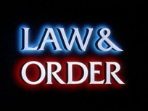
Student Name __________________________________________ Date ________________________ Block _____
Instructions: Use the episode of ‘Law & Order’ to help you write down your responses to the following questions. Be prepared to share your ideas with the class. Turn in your work @ the end of class for a grade.

- How does this episode of ‘Law & Order’ reflect actual events taking place in our culture?

- What is something you learned about the way law enforcement officers do their job?

- What is criminal profiling?

- How could you argue that profiling is acceptable?

- How could you argue that profiling is not acceptable?

- What is something you learned about the way defense attorneys do their job?

- What is something you learned about the way prosecution lawyers do their job?

- What are some possible difficulties people might face in our legal system?

- While the American legal system is not perfect, how could you argue that it is still a good system and the best system for our country?

