‘Flight to Freedom’ Online Game Guide
Student Name ______________________________ Date ____________________ Block _______
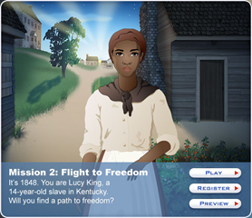
‘It’s 1848. You are Lucy King, a 14-year-old slave in Kentucky. Will you find a path to freedom?’
Instructions: Go to this website http://www.mission-us.org/ and choose to play Mission 2: Flight to Freedom. You will need to register (it’s free) which allows you to have a username and password that you can use to play the game anytime. You need to answer the questions on this worksheet and turn it in for your grade. Don’t forget to save your game as you go. Have fun.
- Based on your gameplay, can you describe what life was like for a Kentucky slave during this time?
__________________________________________________________________________________________________________________________________________________________________________________________________________________________________________________________________________________________________________________________________________________________________________________________________________________________________________________________________________________________________________________________________________________________________
- What specific hardships did you face as a Kentucky slave in the 1840’s? ________________________________________________________________________________________________________________________________________________________________________________________________________________________________________________________________________________________________________________________________________________________________________________________________________________________________________________________________________________________________________________________________________________________________________________________________________________________________________________
- Can you write a brief paragraph describing your journey as Lucy King? ____________________
__________________________________________________________________________________________________________________________________________________________________________________________________________________________________________________________________________________________________________________________________________________________________________________________________________________________________________________________________________________________________________________________________________________________________
- If you had lived in the southern states of America during this time as an African-American slave, do you think you would have tried to run away or would you have stayed on the plantation? Why? _________________________________________________________________________
______________________________________________________________________________________________________________________________________________________________________________________________________________________________________________________________________________________________________________________________________________________________________________________________________
- If you had lived in the southern states of America during this time as a white farmer, do you think you would have viewed slavery as a bad thing or as something that was necessary? Why? ______________________________________________________________________________________________________________________________________________________________________________________________________________________________________________________________________________________________________________________________________________________________________________________________________
- What was your favorite part about the game? Why? ___________________________________
__________________________________________________________________________________________________________________________________________________________________________________________________________________________________________

